Convex and Concave Functions
Convex and Concave Functions - GeeksforGeeks
https://www.geeksforgeeks.org/engineering-mathematics/convex-and-concave-functions/
In mathematics, convex and concave functions describe how curves behave in terms of their curvature. A convex function curves upwards, meaning that a straight line between any two points on the graph will lie above or on the graph. A concave function curves downwards, meaning that the line segment between any two points lies below or on the graph.
Convex Functions
A function f(x) is called convex on an interval if, for any two pointsx1x1​andx2x2​ in the interval and any λ∈[0,1]λ∈[0,1], the following holds:
f(λx1+(1−λ)x2)≤λf(x1)+(1−λ)f(x2)f(λx1​+(1−λ)x2​)≤λf(x1​)+(1−λ)f(x2​)
This means that the function’s graph lies below or on the line segment (chord) connecting any two points on the graph. This property is important in optimization: for convex functions, any local minimum is also a global minimum.
Examples of Convex Functions
Some examples of convex functions are:
- f(x) = x2
- f(x) = ex
- f(x) = |x|
Graphical Representation of Convex Functions
Key graphical features of a convex function:
- Tangent Line: At any point on the graph, the tangent line lies below curve.
- Chord: The line segment connecting any two points on the graph lies above or on the graph.

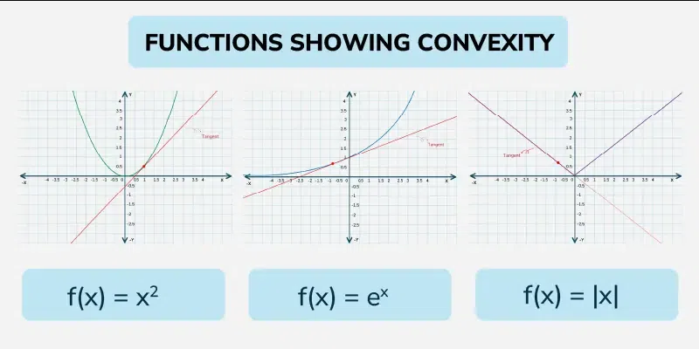
Concave Functions
A function g(x) is called concave on an interval if, for any two points x1x1​ and x2x2​ in the interval and any λ∈[0,1]λ∈[0,1], the following holds:
g(λx1+(1−λ)x2)≥λg(x1)+(1−λ)g(x2)g(λx1​+(1−λ)x2​)≥λg(x1​)+(1−λ)g(x2​)
This implies the graph of the function lies above or on the line segment joining any two points indicating downward curvature.
Examples of Concave Functions
Some examples of concave functions are:
- g(x) = - x2
- g(x) = log x
- g(x) = -ex
Graphical Representation of Concave Functions
Graphical features of a concave function:
- Tangent Line: At any point on the graph, the tangent line lies above the curve.
- Chord: The line segment connecting any two points on the graph lies below or on the graph.
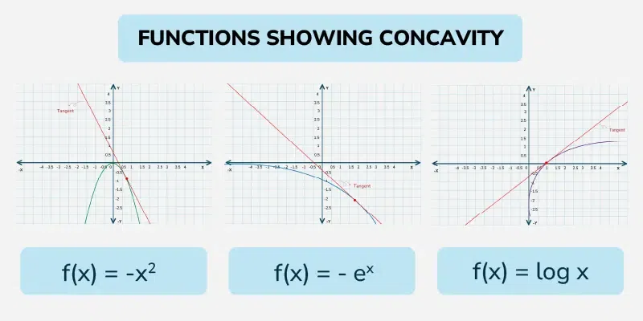
Properties of Convex and Concave Functions
Some common properties related to Concave and Convex Functions are:

First Derivative Test for Convexity/Concavity
A function f(x) is convex, If f′(x) is non-decreasing i.e., f′(x) ≥ 0.
A function f(x) is concave, If f′(x) is non-increasing i.e., f′(x) ≤ 0.
Second Derivative Test
For a function f(x):
If f′′(x) > 0 at a particular point, the function is convex at that point.
If f′′(x) < 0 at a particular point, the function is concave at that point.
If f′′(x) = 0, the second derivative test is inconclusive, and other methods are needed to determine the behavior.
Jensen's Inequality
- If ϕ is a convex function and X is a random variable, then: ϕ(E[X]) ≤ E[ϕ(X)].
- If ϕ is concave, the inequality is reversed: ϕ(E[X]) ≥ E[ϕ(X)].
Convex vs. Concave Functions
Some of the key differences between convex and concave functions are:

Feature | Convex Function | Concave Function
Definition | Lies below or on the chord | Lies above or on the chord
Mathematical Condition | For f(λx1 ​+ (1 − λ)x2​) ≤ λf(x1​) + (1 − λ)f(x2​) where λ∈[0, 1]. | For f(λx1​ + (1 − λ)x2​) ≥ λf(x1​) + (1 − λ)f(x2​) where λ∈[0, 1].
First Derivative | non-decreasing. | non-increasing.
Second Derivative | f′′(x) ≥ 0. | f′′(x) ≤ 0.
Graphical Representation | The graph "bends upwards" or is U-shaped. | The graph "bends downwards" or is inverted U-shaped.
Application | Minimization problems | Maximization problems
Tangent Line | Lies below or on the graph. | Lies above or on the graph.

Solved Problems on Convex and Concave Functions
Problem 1: Show that f(x) = ex is a convex function.
Solution:
First, compute the second derivative of f(x):
f'(x) = ex and f''(x) = ex
Since f''(x) = ex ≥ 0 for all x , f(x) is convex.
Problem 2:Determine if g(x) = -x2 is concave or convex.
Solution:
First, compute the second derivative:
g'(x) = -2x and g''(x) = -2
Since g'(x) = -2 < 0 for all x.
Thus, g(x) is concave.
Problem 3: Minimizef(x)=x2+4x+6f(x)=x2+4x+6.
Solution:
Given: f(x)=x2+4x+6f(x)=x2+4x+6
Now,f′(x)=2x+4f′(x)=2x+4
Set f'(x) = 0 to find the critical point:
2x+4=0⇒x=−22x+4=0⇒x=−2
The second derivative is:
f′′(x)=2f′′(x)=2
Since f''(x) > 0 , the function is convex, and x = -2 is the global minimum. Thus, the minimum value of f(x) is f(-2) = 2 .
Problem 4: Prove that the function f(x)=x2f(x)=x2 is convex using the definition of convexity.
Solution:
By the definition, a function f(x) is convex if for anyλ∈[0,1]λ∈[0,1] and for any two points x1,x2∈Rx1​,x2​∈R, we have:
f(λx1+(1−λ)x2)≤λf(x1)+(1−λ)f(x2)f(λx1​+(1−λ)x2​)≤λf(x1​)+(1−λ)f(x2​)
Consider \( f(x) = x^2 \), then:
f(λx1+(1−λ)x2)=(λx1+(1−λ)x2)2f(λx1​+(1−λ)x2​)=(λx1​+(1−λ)x2​)2
Expanding this expression:
(λx1+(1−λ)x2)2=λ2x12+2λ(1−λ)x1x2+(1−λ)2x22(λx1​+(1−λ)x2​)2=λ2x12​+2λ(1−λ)x1​x2​+(1−λ)2x22​
On the other hand, we have:
λf(x1)+(1−λ)f(x2)=λx12+(1−λ)x22λf(x1​)+(1−λ)f(x2​)=λx12​+(1−λ)x22​
Now, comparing both sides:
λ2x12+2λ(1−λ)x1x2+(1−λ)2x22≤λx12+(1−λ)x22λ2x12​+2λ(1−λ)x1​x2​+(1−λ)2x22​≤λx12​+(1−λ)x22​
Since \2λ(1−λ)x1x2≥0,2λ(1−λ)x1​x2​≥0, the inequality holds. Thus, f(x)=x2f(x)=x2 is convex.
Problem 5: Show that the function f(x)=−x3f(x)=−x3is concave using the first derivative test.
Solution:
First, calculate the first and second derivatives of f(x) :
f′(x)=−3x2andf′′(x)=−6xf′(x)=−3x2andf′′(x)=−6x
- For x≥0x≥0 , f′′(x)=−6x≤0f′′(x)=−6x≤0, so the function is concave for x≥0.x≥0.
- For x < 0 , f′′(x)=−6x≥0f′′(x)=−6x≥0 , but sincef(x)=−x3f(x)=−x3, the function is still concave overall.
Practice Problems: Convex and Concave Functions
Problem 1: Determine if f(x)=x4f(x)=x4is convex or concave.
Problem 2: Prove that f(x)=−exf(x)=−ex is concave.
Problem 3: Identify whether the functionf(x)=log⁡(x)f(x)=log(x)is convex or concave.f(x)=log⁡(x)f(x)=log(x)
Problem 4: For f(x)=x2−4x+4f(x)=x2−4x+4, find the minimum and check if it's convex or concave.
Problem 5: Determine the intervals of convexity and concavity forf(x)=x3−3x2+4xf(x)=x3−3x2+4x.
Problem 6: Check if the function f(x)=∣x∣f(x)=∣x∣ is convex.
Problem 7: Prove that f(x)=cos⁡(x)f(x)=cos(x) is concave on the interval (0,π)(0,π)
Problem 8: Find the critical points and the nature of the function f(x)=x3+3x2−9x+1.f(x)=x3+3x2−9x+1.

Inflection Point
Inflection Point describes a point where the curvature of a curve changes direction. It represents the transition from a concave to a convex shape or vice versa.
Let's learn about Inflection Points in detail, including Concavity of Function and solved examples.
Inflection Point Definition
Inflection Point of a function f(x), is defined by the following two conditions:
Necessary Condition: At inflection point f''(x) = 0 or f''(x) does not exist.
Sufficient Condition: At inflection point concavity of graph changes from concave up to concave down or vice versa i.e., f''(x)<0 before inflection point and f''(x) > 0 after inflection point or vice versa.
Point of inflection is the point where the function goes from being concave upwards to concave downwards and vice-versa. Let's say f(x) is the function that has a point x = c as its inflection point. Then,
- f''(c) = 0
- f''(c) does not exist.
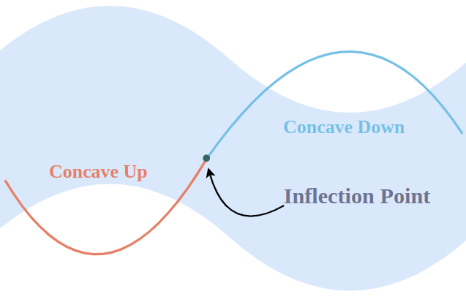
et's learn about concavity for a better understanding of the point of inflection.
Concavity of Function
Consider the two functions given in the figure below, while both of these functions look similar. What differentiates them is their bend, notice that one of them looks opening upwards and the other looks closing downwards. This trend is called concavity.
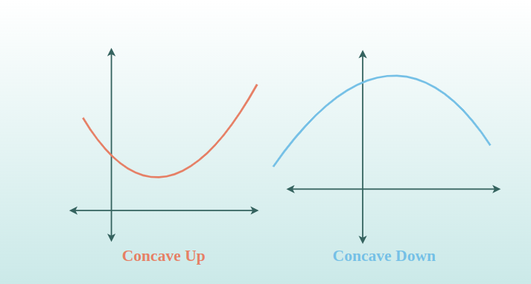

Concavity is related to the rate of the increase as we know that derivatives are nothing but the rate of change. This means they tell us if the function is increasing (rate of change is positive) or decreasing (rate of change is negative).
Thus, Concavity is related to the rate of change of the rate of change, as it is defined in terms of second-order derivative which we will learn about in this article further.
Types of Concavity
There are two types of concavity that exist in the function,
Concave Up
Concave Down
Concave Up: A function is said to be concave up on an interval if the graph of that function lies above any tangent that is drawn on any point of the interval.

Concave Down: Similarly, the function is said to be concave downwards if the graph of the function lies below any tangent that is drawn on any point of the interval.
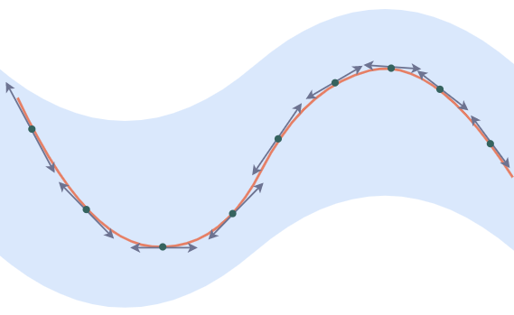

Test for Concavity
Consider a function f(x) which is differentiable and has derivatives and double derivatives as f' and f'' on the interval I.
- f(x) is considered concave up if f''(x) > 0 for all the points in the interval I.
  - f(x) is considered concave down if f''(x) < 0 for all the points in the interval I.

How to Find Inflection Point
We can find the Inflection Point by two methods i.e., Using the Second Derivative (most common method) and Analyzing Changes in the Concavity of the graph (intuitive method). Let's understand these two methods in detail as follows:
Using the Second Derivative
To find the Inflection Point using the second derivative, let's consider a function f(x) and use the following steps for f(x) further:
Step 1: Find the second-order derivative of the given function f(x) i.e., f''(x).
Step 2: Equate the second-order derivative of the given function to 0 and then solve the equation.
Step 3: Check the sufficient condition i.e., f''(x) changes sign at the point where f''(x) = 0.
Step 4: If f''(x) changes the sign at the point of consideration then it is required Inflection Point.
Let's consider an example to understand this better.
Example: Find the inflection point for f(x) = x3 - 3x2 + 4x if exist.
Solution:
Given function if f(x) = x3 - 3x2 + 4x.
Step 1: Find f''(x).
⇒ f'(x) = 3x2 - 6x + 4
⇒ f''(x) = 6x - 6
Step 2: Solve the equation f''(x) = 0.
f''(x) = 6x - 6 = 0
⇒ x = 1
Step 3: Check whether f''(x) changes sign at the point of consideration i.e., x = 1.
Let's choose x = 0.5, then f''(0.5) = -3 (Negative)
Let's choose x = 2, then f''(2) = 6 (Positive)
Step 4: Since f''(x) does change sign at x = 1, it is an inflection point.
Therefore, x = 1 is inflection point in the function f(x) = x3 - 3x2 + 4x.
Note: It is not necessary that if the double derivative is zero at a point, it is an inflection point. For that to be an inflection point, f''(x) needs to change the sign from positive to negative or vice versa.
Related :
- Implicit Differentiation
- Advanced Differentiation
- Absolute Maxima and Minima
Summary - Inflection Point
The articles discuss the concept of inflection points in mathematical functions, emphasizing the necessary conditions for identifying them and their importance in understanding function concavity. An inflection point is defined as a point on a curve where the curvature changes from concave up to concave down, or vice versa. This transition is identified by either the second derivative of the function being zero or non-existent at that point. The articles further explore how concavity affects the shape of a curve, with concave up sections appearing as upward bends and concave down sections as downward bends. Various methods for determining inflection points and concavity are detailed, primarily focusing on the use of the second derivative test. Practical examples and solved problems are provided to illustrate how to apply these methods to specific functions, helping to clarify the theoretical concepts with real-world applications. Concavity tests and the impact of curvature changes on function behavior are emphasized as vital tools in calculus, offering insights into the properties and extremities of curves.
Sample Problems on Inflection Point
Problem 1: Find out the concavity of the given function between the interval [0,1].
f(x) = x2 + 4
Solution:
To check for the concavity, let's look at the second derivative of the function.
f(x) = x2 + 4
Differentiating w.r.t x,
f'(x) = 2x
Differentiating w.r.t x again,
f''(x) = 2 > 0
This is greater than zero, the function is concave upwards in the given interval.
Problem 2: Find out the concavity of the given function between the interval [2,4].
f(x) = x3 + 4
Solution:
To check for the concavity, let's look at the second derivative of the function.
f(x) = x3
Differentiating w.r.t x,
f'(x) = 3x2
Differentiating w.r.t x again,
f''(x) = 6x > 0
This is greater than zero, the function is concave upwards in the given interval.
Problem 3: Find inflection point for the given function.
f(x) = x3
Solution:
To check for the point of inflection., let's look at the second derivative of the function.
f(x) = x3 + 4
Differentiating w.r.t x,
f'(x) = 3x2
Differentiating w.r.t x again,
f''(x) = 6x = 0
Solving f''(x) = 0, it shows that x = 0 is the critical point of f'(x).
Now let's check the value of f''(x) before and after the critical point.
for x < 0, f''(x) < 0.
for x > 0, f''(x) > 0.
Thus, the function changes from concave downward to concave upward. Thus, x = 0 is the inflection point.
Problem 4: Find inflection point for the given function.
f(x) = x3 + x2 + 3
Solution:
To check for the point of inflection., let's look at the second derivative of the function.
f(x) = x3 + x2 + 3
Differentiating w.r.t x,
f'(x) = 3x2 + 2x
Differentiating w.r.t x again,
f''(x) = 6x + 2 = 0
Solving f''(x) = 0, it shows that x = -1/3 is the critical point of f'(x).
Now let's check the value of f''(x) before and after the critical point.
for x < -1, f''(x) < 0.
for x > 0, f''(x) > 0.
Thus, the function changes from concave downward to concave upward. Thus, x
= -1/3 is the inflection point.

Real Life Application of convexity and concavity of Graphs
Convexity and concavity are terms used to describe the shapes of graphs. A convex graph curves upward, while a concave graph curves downward. These shapes play important roles in various real-life situations. They are used in fields like economics and engineering. They help experts make informed decisions and predictions.
This article discusses the real-life uses of convexity and concavity of graphs.
What is Convexity of Graphs?
Convexity of graphs refers to a property where the curve represented by the graph bulges upwards or lies above the line segment connecting any two points on the graph.
n simpler terms, if you were to draw a straight line between any two points on the graph, the curve would always lie above this line. This property is similar to the shape of a bowl or a hill, where the curve always arches upwards.

A common example is the parabola y = x2, which is convex on its entire domain.

What is Concavity of Graphs?
Concavity of graphs refers to a property where the curve represented by the graph curves downwards or lies below the line segment connecting any two points on the graph.

In simpler terms, if you were to draw a straight line between any two points on the graph, the curve would always lie below this line. This property is similar to the shape of a valley or a bowl turned upside down, where the curve always arches downwards.
An example of a concave function is y = -x2, showing a typical downward opening parabola.
Real-life Application of Convexity and Concavity of Graphs
Some of the common real-life applications of convexity and concavity of graphs are :
Transportation and Traffic Flow
In transportation and traffic flow, convexity and concavity help optimize routes and manage congestion. By analyzing graphs that show traffic patterns, we can identify peaks and troughs in traffic flow. Convex regions might indicate steadily increasing traffic, while concave regions could show where traffic starts to decrease. This information allows planners to implement effective traffic control measures, like timed lights or congestion charges, to smooth out the flow.
Examples:
- Graphing traffic volume over time to identify high congestion periods.
- Analyzing speed versus time on different road segments to optimize signal timings.
- Studying the flow of vehicles in and out of a parking garage to manage entry and exit points.
Environmental Science
The convexity and concavity of graphs are used to model phenomena like population growth and pollutant dispersion. A concave curve might show a rapid increase in pollution levels, suggesting a quick response is needed. On the other hand, a convex curve could indicate a slowing down of growth or spread, showing efforts are working or that an issue is less urgent.
Examples:
- Modeling animal populations in an ecosystem to determine sustainable levels.
- Tracking pollutant levels over time in water sources to assess the effectiveness of cleanup measures.
- Graphing deforestation rates to plan reforestation initiatives.
Architecture and Design
Understanding the convexity and concavity of structural load graphs helps ensure safety and efficiency. Structures are designed to handle loads based on these curves, with concave sections indicating potential areas of stress concentration and convex sections often representing more stable areas. This analysis helps in material selection and structural layout.
Examples:
- Designing beams and columns in buildings to withstand expected loads.
- Analyzing foot traffic patterns in large structures to enhance flow and reduce bottlenecks.
- Creating efficient layouts in urban design to maximize usable space.
Sports and Fitness
Sports and fitness often use graphs to monitor performance and health metrics. A convex curve in a graph showing running speed versus time could indicate a plateau, suggesting a need for a change in training. A concave curve may show rapid improvement, guiding how much to intensify the training without risking injury.
Examples:
- Tracking an athlete’s running speed over several months to tailor training programs.
- Monitoring heart rate during different exercises to optimize cardiovascular impact.
- Analyzing recovery times post-exercise to prevent overtraining.
Optics and Lenses
The shape of lenses and the bending of light are analyzed using convex and concave graphs. Convex curves can represent the focusing of light rays, ideal for corrective lenses that need to converge light on the retina. Concave curves help in designing lenses that diverge light, used in applications like minimizing glare.
Examples:
- Designing eyeglasses to correct nearsightedness or farsightedness.
- Creating camera lenses that adjust light focus for clear images.
- Developing optical instruments like microscopes and telescopes for enhanced viewing.
Health and Fitness Tracking
Health and fitness tracking uses convexity and concavity to interpret biometric data. For instance, a convex glucose level graph might indicate a need for dietary adjustment in diabetics. Concave trends in weight loss graphs can show significant progress, motivating continued effort or adjustment in diet and exercise regimes.
Examples:
- Monitoring blood sugar levels in diabetic patients to manage insulin dosage.
- Tracking weight loss over time to assess diet and exercise effectiveness.
- Analyzing sleep patterns to improve quality and duration of sleep.
Economics and Finance
Convexity and concavity are crucial in analyzing investment returns and risk management. Convex curves often represent increasing returns, signaling a good investment under certain conditions.
Concave curves, on the other hand, can indicate diminishing returns, prompting a reevaluation of strategies. These concepts help investors and companies make informed decisions about where to allocate resources for maximum benefit.
Examples:
- Tracking stock price movements over time to identify growth patterns.
- Analyzing the risk-return profile of different investment portfolios.
- Projecting economic indicators like GDP growth to guide fiscal policy decisions.
Manufacturing and Production
The convexity and concavity of cost, production, and efficiency graphs help optimize operations. A convex graph in production costs as volume increases might suggest economies of scale, where costs per unit decrease. Conversely, a concave graph could indicate increasing marginal costs, helping businesses decide optimal production levels to maximize profit.
Examples:
- Monitoring assembly line speeds against output to find optimal production rates.
- Graphing material costs versus production volume to identify cost-effective procurement strategies.
- Analyzing downtime and maintenance costs to schedule efficient machine upkeep.
Technology and Computing
onvex and concave graphs are used in algorithm efficiency and resource allocation. Convexity can indicate good scalability of a process as resources increase, whereas concavity might suggest inefficiencies that become more pronounced with scale. These insights guide software development and system design to improve performance and user satisfaction.
Examples:
- Evaluating the time complexity of algorithms to optimize computing processes.
- Assessing server response times as user numbers increase to plan capacity upgrades.
- Analyzing battery usage patterns in devices to enhance power management.
Healthcare and Medicine
The analysis of convex and concave curves can assist in diagnosis and treatment planning. For example, a concave curve in a patient’s recovery chart might indicate rapid improvement, whereas a convex curve could suggest a slower recovery, affecting treatment approaches and patient care strategies.
Examples:
- Charting disease progression over time to tailor individualized treatment plans.
- Monitoring patient vital signs to detect early signs of deterioration or improvement.
- Analyzing population health trends to allocate healthcare resources effectively.

